**SUPPORT VECTOR MACHINE**

**Business Problem** = ﻿﻿﻿﻿﻿﻿Prepare a classification model using SVM for salary data.

* **Name of the File: -** SalaryData_Train.csv, SalaryData_Test.csv
* **Size of the File: -** 3.4 MB + 1.7 MB
* **Necessary Data : -** 30161 Train Observations, 15060 Test Observations, 14 Features.

**Exploratory data Analysis** =

* **Missing Value: -** Data don’t have Missing Values
* **Output:** - Categorical
* **Sampling:**- Already Sampled

**Model Building =** Building the SVM model by considering linear kernel.

* **Accuracy Score Train:-** 85 %
* **Accuracy Score Test:-** 85 %
* 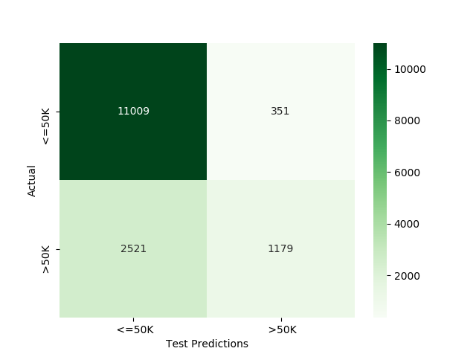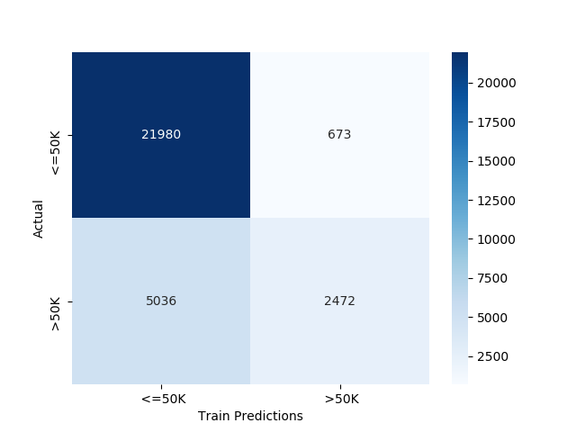**Confusion Matrix : -**

**Python code file**: - [Salary Data Analysis.py](https://github.com/nilaydeshmukh0/Support-Vector-Machine/blob/master/Salary%20Data%20Analysis/Salary%20Data%20Analysis.py)